# Main Page Code

import 'package:flutter/material.dart';  
import 'package:sample_flutter/pass_data_bw_screen/product%20list%20screen.dart';  
  
import 'Single products.dart';  
  
void main(){  
 runApp(MyApp());  
  
}  
class MyApp extends StatelessWidget{  
 @override  
 Widget build(BuildContext context) {  
 return MaterialApp(  
 debugShowCheckedModeBanner: false,  
 home: ProductList(),  
 routes: {  
 "single-product": (context)=> const SingleProductScreen(),  
 },  
 );  
  
 }  
  
}

# Product List Page

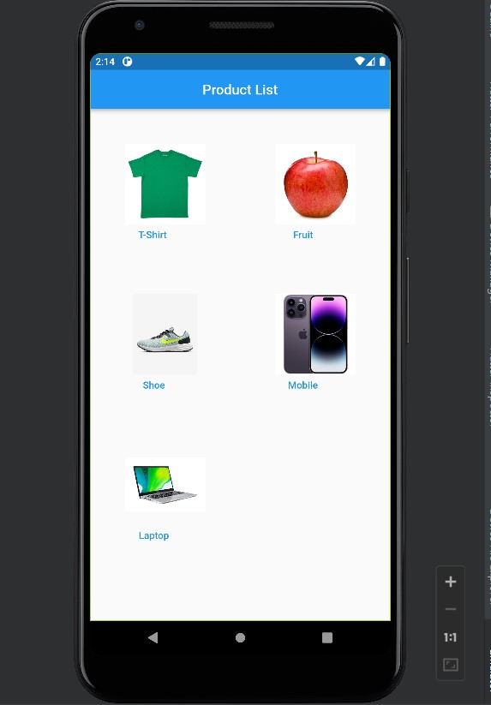

import 'package:flutter/material.dart';  
import 'package:sample_flutter/pass_data_bw_screen/product%20list%20screen.dart';  
  
import 'Single products.dart';  
  
void main(){  
 runApp(MyApp());  
  
}  
class MyApp extends StatelessWidget{  
 @override  
 Widget build(BuildContext context) {  
 return MaterialApp(  
 debugShowCheckedModeBanner: false,  
 home: ProductList(),  
 routes: {  
 "single-product": (context)=> const SingleProductScreen(),  
 },  
 );  
  
 }  
  
}

# 

# Single Products Page

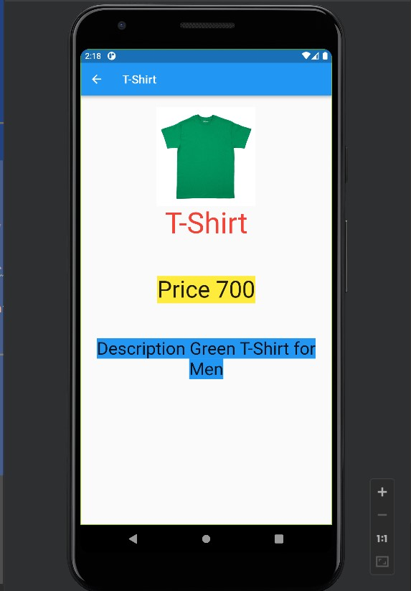

import 'package:flutter/material.dart';  
import 'package:sample_flutter/pass_data_bw_screen/dummy%20data.dart';  
  
class SingleProductScreen extends StatelessWidget{  
 const SingleProductScreen({super.key});  
  
 @override  
 Widget build(BuildContext context) {  
 final productId = ModalRoute.*of*(context)?.settings.arguments;  
 final Product = dummyProducts.firstWhere((e) =>e['id']== productId);  
  
 return Scaffold(  
 appBar: AppBar(title:  
 Text(Product['name']),  
 ),  
 body: Padding(  
 padding:const EdgeInsets.all(20),  
child: ListView(  
 children: [  
 Image(image: NetworkImage('${Product['image']}'),  
 height: 170,  
 width: double.*infinity*,  
 ),  
 Text('${Product['name']}',  
 style:const TextStyle(fontSize: 50, color: Colors.*red*),textAlign: TextAlign.center,),  
 const Padding(padding: EdgeInsets.all(30)),  
 Text('Price ${Product['price'].toString()}',style:TextStyle(fontSize: 40, backgroundColor: Colors.*yellow*),textAlign: TextAlign.center,),  
 const Padding(padding: EdgeInsets.all(30)),  
Text('Description ${Product['description']}',style: TextStyle(fontSize: 30, background: Paint()..color = Colors.*blue*),textAlign: TextAlign.center,),  
 const Padding(padding: EdgeInsets.all(30)),  
  
 ],  
),  
 ),  
 );  
 }  
  
}

# DummyList Page

const List<Map<String, dynamic>> dummyProducts = [  
 {  
 'id': 1,  
 "name": "T-Shirt ",  
 "price": 700,  
 "description": "Green T-Shirt for Men",  
 "image" : "https://imgprd19.hobbylobby.com/2/4f/57/24f57e245a879cb2543edd1df4e090bfebf24a45/700Wx700H-1013689-0320.jpg",  
 },  
 {  
 'id': 2,  
 "name": "Fruit ",  
 "price": 140,  
 "description": "Kashmir Apple 1Kg",  
 "image" : "https://media.istockphoto.com/id/184276818/photo/red-apple.jpg?s=612x612&w=0&k=20&c=NvO-bLsG0DJ_7Ii8SSVoKLurzjmV0Qi4eGfn6nW3l5w=",  
 },  
 {  
 'id': 3,  
 "name": "Shoe",  
 "price": 1200,  
 "description": "Nike Running Sports shoe",  
 "image" : "https://static.nike.com/a/images/t_PDP_1280_v1/f_auto,q_auto:eco/ed291e67-4618-49ec-8dda-2c2221a5df41/revolution-6-next-nature-mens-road-running-shoes-FgfhgR.png",  
 },  
 {  
 'id': 4,  
 "name": "Mobile ",  
 "price": 50000,  
 "description": "Apple 11 pro 256Gb Silver",  
 "image" : "https://kddi-h.assetsadobe3.com/is/image/content/dam/au-com/mobile/mb_img_58.jpg?scl=1",  
 },  
 {  
 'id': 5,  
 "name": "Laptop",  
 "price": 3000,  
 "description": "Asus Pavilon i7 1Tb SSD 8Gb Ram",  
 "image" : "https://cdn.thewirecutter.com/wp-content/media/2022/07/laptop-under-500-2048px-acer-1.jpg",  
 },  
  
];